OPTIMUM NEUTRAL POSTURE
FOR SEATED COMPUTER OPERATORS

Improperly designed workplace environments frequently result in computer operators assuming work positions outside of an optimum neutral posture comfort zone. Significant medical and health considerations exist for advocating optimal neutral posture for seated workers. These health considerations provide significant justification for, and a strong incentive to provide, ergonomically correct computer work environments.

Conservation of Energy

Approximately 70% to 80% of human energy is expended in the maintenance of the body's mass in space and the movement of the body's mass through space.

As a survival mechanism, humans have an innate desire to conserve energy. The least amount of energy expenditure occurs when the body's mass is maintained in a balanced position over its base of support.

Based upon anthropometric data, the human head weighs between 8 and 14 pounds (proportionate to total body mass). The mechanical support structures for the maintenance of the head's position in space during dynamic movement or stationary postures, are the spinal vertebrae and discs; an intricate network of ligaments, cartilage and joint capsules, and numerous pairs of counterbalancing muscles in front, back and either side.

Optimal Work Posture - The Comfort Zone

For seated workers, the optimal position of the head is in the neutral posture, which means that the head is centered over the midline of the body when viewed from either the antero-postero or lateral plane, or with a slight (normal) forward lean (5º). The neutral posture places the smallest demand on energy expenditure and results in the least amount of structural stress and related fatigue. See Figure 1.

The neutral posture also helps to preserve the normal antero-postero arc of the cervical spine (neck vertebrae). The four counterbalancing antero-postero arcs of the spinal column are designed to absorb shock and reduce structural and gravitational stress on the spine, which serves to protect the brain stem, spinal cord and attached network of spinal nerves and their functions.

Visual Considerations

While maintaining the head in its optimal, neutral posture, relaxed vertical and horizontal eye movements can occur up to 35 degrees without significant movement of the head away from neutral. See Figures 1 and 2.

Abnormal Work Postures - Faulty Biomechanics

Static work postures that require a shift of the head away from the neutral posture, either in flexion, extension, rotation or lateral flexion to the right or left, result in imbalanced, asymmetrical muscle loading.

When unbalanced static muscle loading is experienced repeatedly and for prolonged periods, it results in a build-up of toxic waste products within the muscle chemistry, causing fatigue and loss of efficiency. In addition, abnormal work postures produce asymmetrical compression on spinal discs and excessive mechanical stress on the supportive ligaments and joint capsules.

Over time, the consequences of asymmetrical spinal loading can result in degenerative disc and joint disease with resultant irritation and inflammation of the nerves that exit from the openings on either side of the vertebrae. The nerves in the neck region provide the sensory and motor control to the back of the skull, neck and upper back muscles, shoulders, elbows, forearms, wrists, hands and fingers. These nerves also regulate the blood and lymph circulation, providing oxygen and nutrients to and waste product removal from these tissues.

Medical Considerations

Human factors engineers (ergonomists) as well as physicians involved in the diagnosis and clinical management of the common neuromusculoskeletal disorders of seated workers have long recognized the correlation of faulty work postures and a variety of painful and often temporarily disabling syndromes relating to the cervical spine. Among these disorders are tension, migraine and cluster headaches; neck stiffness, pain and spasm; back pain; thoracic outlet syndrome; infraspinatous, scalenus anticus and pronator terres syndromes; shoulder, elbow, forearm and wrist tendonitis and entrapment disorders of the wrist and hand, including carpal tunnel syndrome. There is an extensive field of published scientific literature supporting the above clinical correlations.

It is common for employees, supervisors and health care providers to misdiagnose carpal tunnel syndrome when in reality the symptoms can be a manifestation of combinations of the above spine related disorders, often caused by or aggravated by faulty work postures among sedentary workers.

An Aging Population of Workers

The neuromusculoskeletal concerns expressed above are currently particularly relevant with our aging population of sedentary workers. Neck pain and stiffness, upper spinal stress, headaches and upper extremity disorders are often provoked or aggravated in middle age workers who transition from single lens to bifocal or trifocal eyeglasses. To accommodate the mid-range visual need to focus on information provided on computer monitor screens, workers often extend their neck into undesirable, stressful postures.
While most health care providers recommend that such workers obtain a separate pair of single lens eyeglasses that are ground expressly for optimal vision at that particular distance, not all workers comply with this advice. Cost factors and inconvenience are reasons cited for resistance to such recommendations. Computer monitors with adjustable height screens provide workers requiring corrective lenses with a wider range of options in maintaining neutral posture.

Ergonomic Considerations

When designing an ergonomically correct computer workstation, the workstation designer or ergonomist must keep in mind that even the ideal neutral posture can be harmful if maintained for extended periods of time. Accordingly workers should be encouraged to take short work breaks and to change their posture repeatedly throughout the day. To save costs, design(s) should be chosen that could accommodate a range of users representing a majority of all operators in a seated computer work environment.

To address these issues it is important that the computer work environment be designed with vertically adjustable and tiltable monitor and keyboard components to provide an “optimum neutral posture viewing cone” for a range of operators as shown in Figure 2.

Figure 2, along with the accompanying notes, illustrates how the components of a computer workstation can be structured to maintain the optimum neutral posture as the workstation transitions from the eye height of the average male operator to the eye height of the average female operator. If the monitor mounting system is dynamically adjustable, i.e., easy to adjust, the operator can vertically adjust and/or tilt the viewing cone to maintain neutral posture when assuming alternate seating postures. By equipping the workstation with viewing screen and keyboard height adjustability ranges of 110 mm to 130mm (approximately 4.3” to 5.1”), the relationship of these two key components can be maintained over the entire adjustment range. This arrangement allows use of standard height desk surfaces for a majority of workers in seated environments with resultant significant cost savings.

Dr. Joseph J. Sweere Harry C. Sweere
Professor, Department of Clinical Sciences Chairman, Chief Scientist
Chairman, Department of Occupational Health Ergotron, Inc.
Northwestern Health Sciences University Constant Force Technology, LLC
Bloomington, Minnesota St. Paul, Minnesota
jsweere@nwhealth.edu hsweere@ergotron.com

Figure 1

Optimum Neutral Posture for Seated Computer Operators

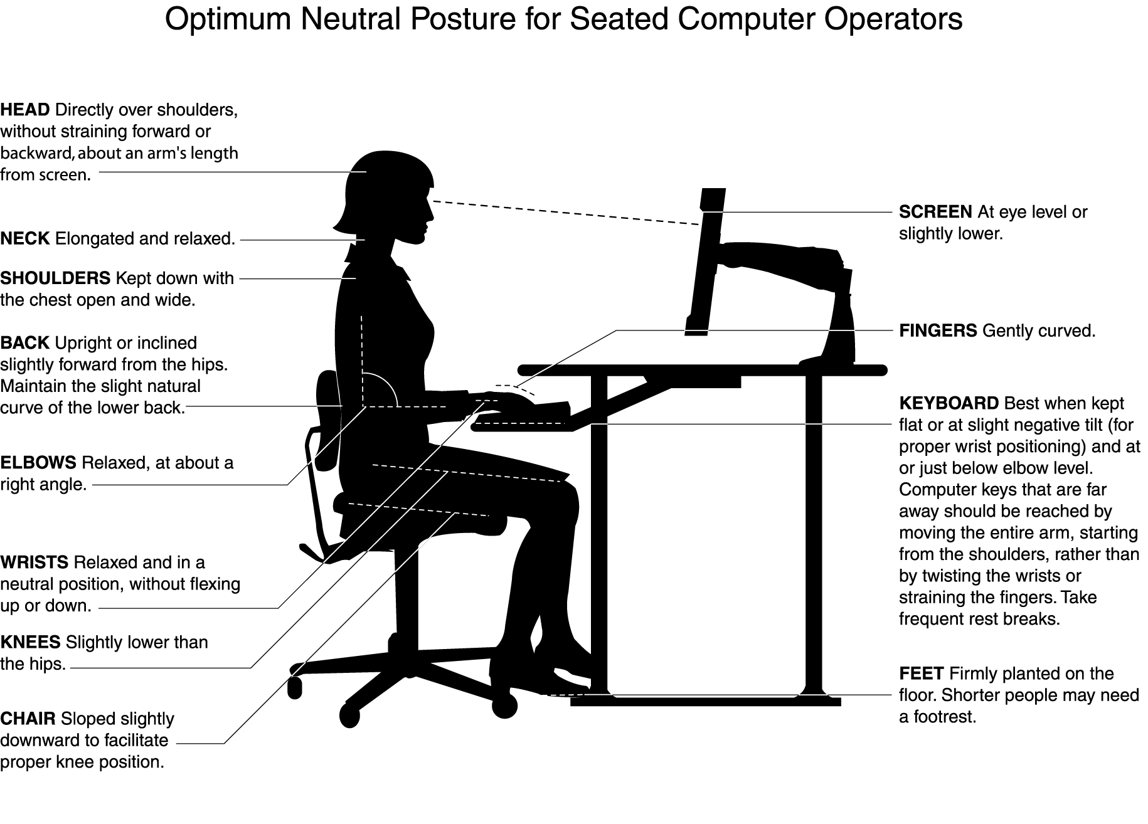

Figure 2

Optimum Viewing Cone Designed to Minimize Musculoskeletal Stress Disorders

Notes:

 Viewing distance, 460mm to 700mm (18” to 28”)

 Top of screen, set 25mm (1”) below horizontal

 First line of text, 5º below horizontal

 Viewing cone, 5º to 35º below horizontal

 Centerline of screen, 15º to 20º below horizontal

 Vertical adjustment range, minimum 110mm to ideal 130mm (4.3” to 5.1”) for average range of male to female users. For 5% female to 95% male range of users, viewing cone should adjust 287mm (11.3”)

 Screen tilt range, -5º to +30º (minimum
-5º to +20º) to maintain constant focal length

 Mounting devices vertically position screen and keyboard to provide optimum viewing cone and keyboard relationship for a range of operators

- Keyboard position = 330mm (21”) below eye height – vertically adjustable so relationship of eye height and centerline of keyboard can be maintained throughout range of users

